INTRODUCTION:
Forced vibration is the one in which external energy is added to the vibrating system. The amplitude of a forced-undamped vibration would increase over time until the mechanism was destroyed. The amplitude of a forced-damped vibration will settle to some value where the energy loss per cycle is exactly balanced by the energy gained.
Examples of this type of vibration include a structure subjected to vibrating machines, vibration of a building during an earthquake or under the action of wind, etc.
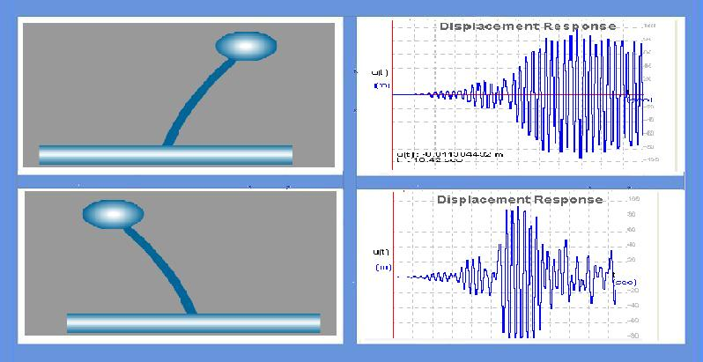
THEORY:

Forced vibration is of two types:
1. undamped forced vibration
2. damped forced vibration
Undamped forced vibration :

The differential governing equation for system without damping is mü + ku = posinωt
where, m = mass; ü = acceleration; k = stiffness; u = displacement; ωn= natural frequency; po= amplitude of force.
Solution of the given equation is
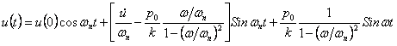

where,
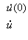
= Initial Velocity.
= Velocity.
Damped forced vibration:
The amplitude of a forced value where the energy loss per cycle is exactly balanced by the energy gained. The governing equation for damped forced vibration is
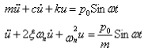
Where,
c = Damping Coefficient.
ξ = Damping Ratio.
The Solution for the given Equation is
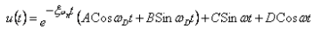
Where, ω D = Damped Frequency.
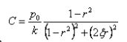
Where,

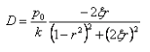

Also, r = Frequency Ratio.

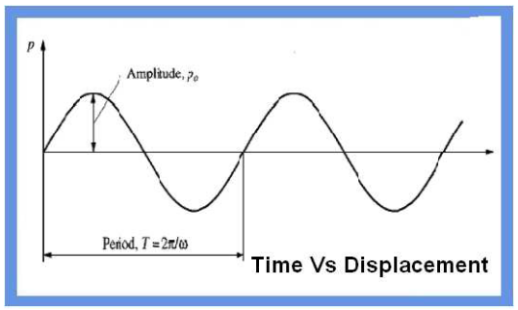

OBJECTIVE:

To understand the behavior of the single degree of freedom system when time varying force i.e ground motion is applied.
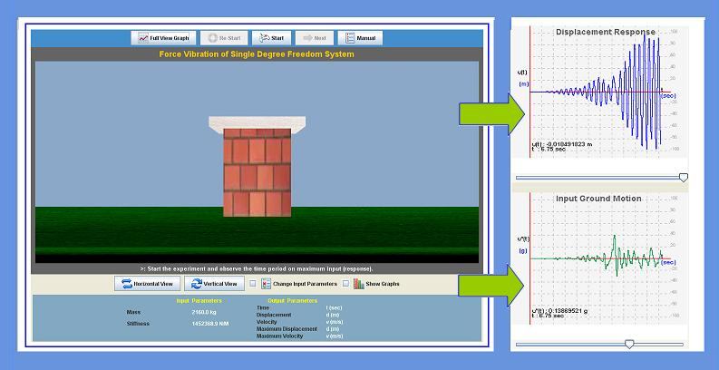

MANUAL:
Observation 1: Effect of time period on maximum response
1. Run the experiment with default ground motion and building parameters
2. Observe the response and note down the maximum response.
3. Repeat the experiment by changing the values of mass of the structure. (Note: Change in mass will change the time period of the structure)
4. Note the maximum response.
5. Plot the graph between the maximum response and the time period of the structure.
Observation 2: Effect of resonance without damping
6. Select Resonance from the list of earthquakes. And set damping to Zero
7. Run the experiment and note the displacement.
8. Response value increases and reaches peak when forcing frequency is nearing natural frequency of the structure.
9. Draw the plot between maximum response and frequency ratio.
Observation 3: Effect of resonance with damping
10. Select Resonance from the list of earthquakes. And set damping to Zero
11. Run the experiment and note the displacement.
12. Response value increases and reaches peak when forcing frequency is nearing natural frequency of the structure.
13. Draw the plot between maximum response and frequency ratio.

PART - 2
ANIMATION STEPS
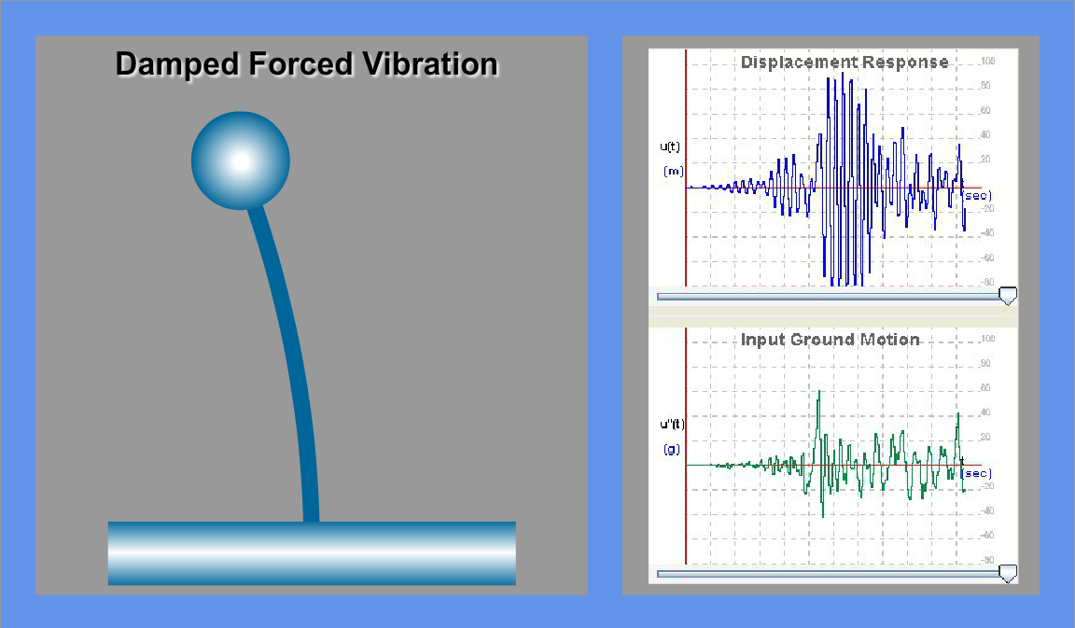

PART – 3
VIRTUAL LAB FRAME
